[ACDS Introduction.pdf](https://confluence.kroger.com/confluence/display/8451MERCH/3CM+Tools%2C+Libraries%2C+and+Sources+Overview?preview=%2F392431509%2F392442815%2FACDS+Introduction.pdf) Brief

•

Data Mart – a collection of data assets that can be used together

to answer business questions, comprised individual data assets

that are either facts or dimensions, typically built with a specific

purpose in mind

Facts – a data asset containing recorded values of some

transactional or business process

Dimension – a data asset containing information about the

attributes of a given domain (product, store, date, household)

Derived – for example, segmentations are considered somewhere

in between fact and dimensions, these are considered as historic

records, tied to a specific point in time

© 84.51 ̊ | 2022 | CONFIDENTIAL |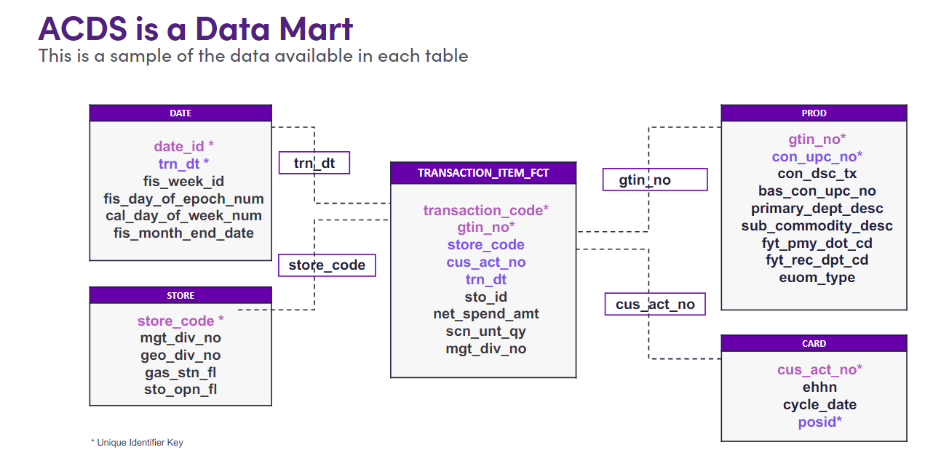

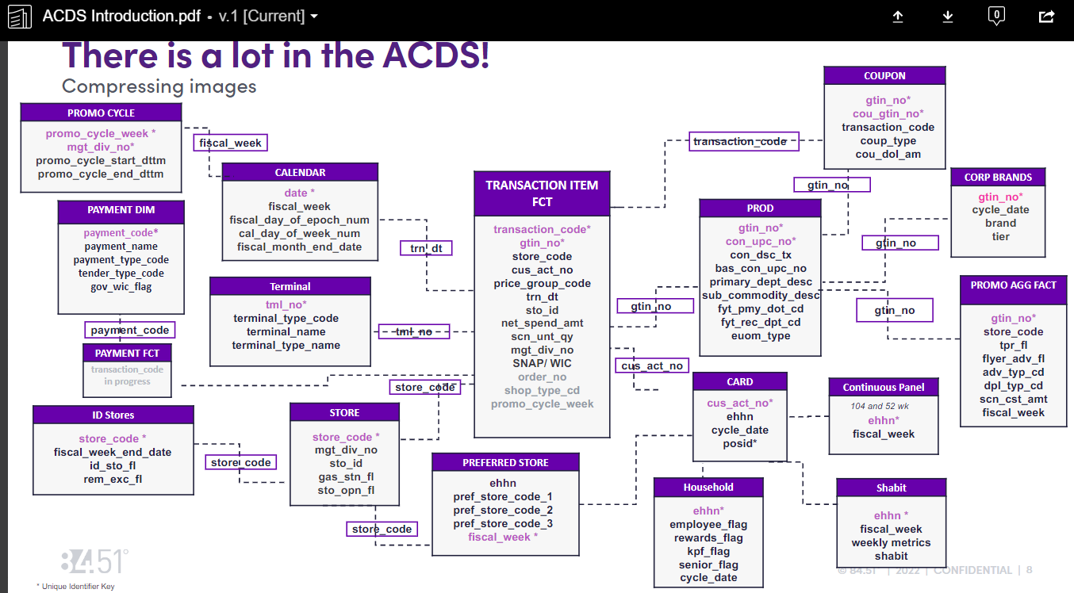

[Transaction Item Fact](https://krogerpedia.kroger.com/asset/39567e66-dd5e-4aa7-90d6-539c317443f8?type=dataset2)

* Key: transaction_code, gtin_no:
* Provides details about every item scanned at Kroger.
* To speed up development and minimize cost, we should use the sample mart (subset of our
* transaction data).
* This a simple sample (1% of households) and should not be used as a statistical sample.
* Default parameter in Effodat

[Product Dimension](https://krogerpedia.kroger.com/asset/659b1377-7a20-4b17-a0e5-32f7d6f3202b?type=dataset2)

•Key: gtin_no

•Information about products from PID (Kroger), but not comprehensive of all product attributes.

•Contains enterprise product hierarchy. We use the PID hierarchy. Learn more [here](https://confluence.kroger.com/confluence/display/8451DG/Product+Hierarchies).

•Learn more about UPCs [here](https://github.8451.com/Analytics-Tools/upc_input_py/blob/master/docs/example_notebooks/01_upc_key_terms.ipynb)

.

–Scan UPC

–Base UPC

–PLU (global and retailer)

Markdown

–RPB

Store Dimension

• Key: store_code

• Watch out! Store numbers are not unique!

• Use geo_div_no, instead of mgt_div_no, to identify identify division.

• Do not use sto_opn_fl to determine if a store is open. Instead join the store dimension to transactions and pull stores with valid transactions within a recent timeframe

Card Dimension

• Key: cus_act_no (Yue : not in acds_transactions.xlsx but ehhn: Enterprise Household Number)

• You should pull the card to household relationship from the transaction table, rather than card dimension.

• Kroger householding

• Based off name and address

• Card to person has a many to one relationship

• Person to household has a many to one relationship

• Card to household has a many to one relationship

• The relationship can change over time

• Learn more here - [Current Kroger Householding Process](https://confluence.kroger.com/confluence/pages/viewpage.action?spaceKey=8451DG&title=Current+Kroger+Householding+Process)

Date Dimension

• Key: date

• Contains information to relate dates to Kroger fiscal calendar

• Check out [kayday](https://github.8451.com/Analytics-Tools/kayday), an internal package for handling Kroger dates. Note, much of kayday’s functionality is inherited by Effodata and KPI Aggregator.

(Yue: the link <https://github.8451.com/Analytics-Tools/kayday> for Kayday is NW)

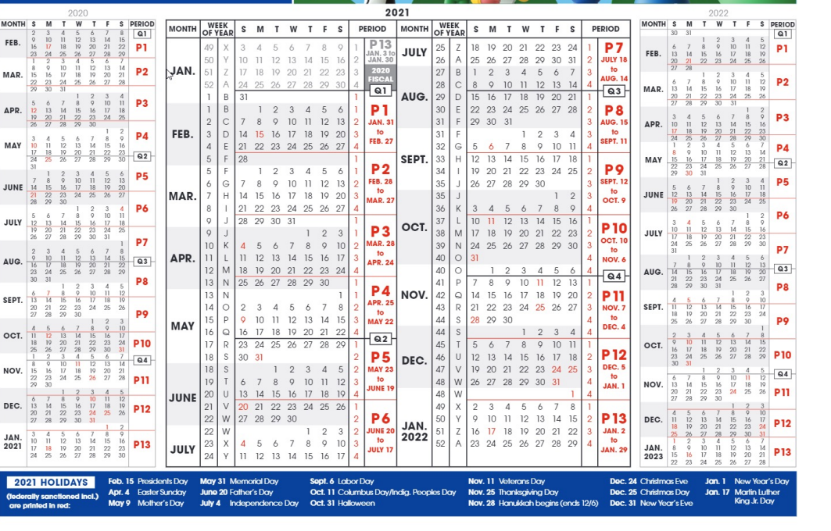

**Which ACDS asset contains each data point?**

